**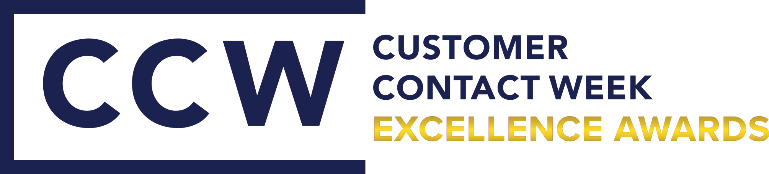  
CCW Excellence Awards 2026 Application Form  
*Best AI Project of the Year 2026***

The Annual CCW Excellence Awards are in recognition of the hard work, talent and growing initiatives the contact centre and CX community has demonstrated over the past year.

We have reinvigorated the **Customer Contact Week Excellence Awards** program this year to recognise those organisations, teams and individuals who are making the greatest contributions to future customer service.

**How do I apply?**

In 2026, CCW is all about putting the team, the people at the heart of the application – and we want to see your faces!

**Who can apply?**

Everyone can apply for the awards. If you are a solution provider who has achieved incredible things with one of your customers, we recommend you encourage them to submit an application on your behalf.

**How are they judged?**

All applications judged by an expert panel of leaders within the customer contact community.

The winners are selected through an in-depth scoring card by the judges.

**When can I apply?**

If you’d like to apply for an Award, please submit this completed application before **12 December 2025**, and return to [customercontactweek@iqpc.com.au](mailto:customercontactweek@iqpc.com.au)

**When will the finalists be announced?**

The finalists will be announced in Feb 2026. You will be contacted directly if you have made this shortlist.

**Where will the awards winners be announced?**

Winners are announced during the Awards Dinner Drinks Reception & Party at the Customer Contact Week, on 18th March 2026.

**What happens if I win?**

Award Winners will receive:

* Award trophy
* Certificate
* Published coverage on the Customer Contact Week website and social media channels
* Featured articles and interviews with the Customer Contact Week team

**BEGIN YOUR APPLICATION NOW…**

**General Information about You and Your Organization**

|  |  |
| --- | --- |
| **Authorised by:** |  |
| **Date:** |  |
| **Name of Contact Person:** |  |
| **Job Title:** |  |
| **Organisation:** |  |
| **Phone Number:** |  |
| **Email Address:** |  |
| **PR Contact (for promotion of award winners):** |  |
| **Phone Number for PR Contact:** |  |

**Please provide the following information to provide the judges better understanding of your contact centre**

|  |  |
| --- | --- |
| **Organisation Name:** |  |
| **Number of Contact Centre Locations:** |  |
| **Number of Full Time Employees:** |  |
| **List your top 3 technology vendors:** | **1.**  **2.**  **3.** |
| **List your top 3 non-technology vendors (i.e. consultants):** | **1.**  **2.**  **3.** |
| **Type of centre (i.e. internal contact centre, sales contact centre, customer service centre):** |  |
| **Inbound, outbound or both:** |  |
| **B2B, B2C or both:** |  |

**YOUR APPLICATION FOR**

**Best AI Project of the Year 2026**Celebrating digital delivery and effective channel management across the organisation.

Please note: The key “showcase” for the award should be for **something you’ve achieved in the past year**.

Please ensure all questions are answered so the judges can accurately compare.

Please include supporting metrics wherever possible.

**Question 1:** Describe the problem you were facing in the contact centre and why you sought AI as a reason to approach it. This can be a proof of concept solution or fully scaled AI solution.

**Question 2:** How did you implement AI? What key challenges did you face and overcome on the journey?

**Question 3:** What has the result of the AI been on the contact centre? Please reference its impact on the agents and/or customer

**Do you grant the Customer Contact Week team the right to publish key metrics and promote Winners of Awards? (Please mark appropriate boxes)**

|  |  |
| --- | --- |
|  | Grant CCW the right to publish our key metrics if we become finalists |
|  | CCW may extract the details directly from the Award application |
|  | CCW may utilise a condensed version for public view upon the approval of the Point of Contact  listed on the application form |

Thank You!

Your application has been completed.

Please email this application and any supporting documents to: [customercontactweek@iqpc.com.au](mailto:customercontactweek@iqpc.com.au)

*ELIGIBILITY TERMS*

1. The CCW Excellence Awards recognise best practice in the customer contact and service industry. They are open to application by contact centre leaders across Australia, New Zealand and the broader APAC region.
2. Entries may be submitted by the organisation itself, their marketing department or any other third party organisation. It will be the name of the entry organisation and their submitted project, person or business that will be noted on the short list, winner’s announcement, trophies and any printed or online material.
3. Criteria within each category are designed to recognise initiatives completed over the last 18 months. Unless stated otherwise, as a guideline we ask companies to focus on submitting projects and initiatives that have been undertaken in the past year. We do however recognise that some may have started earlier than this and are yet to be completed and therefore we can be flexible with this rule.
4. Confidentiality within the entry and judging system is considered the most important feature of the awards programme. We guarantee the security and confidentiality of the information provided within the entry.
5. The Awards Night is available for sponsorship and are considered event partners. Any companies associated with the event or category partnership have no influence over entries, short listing, judging or winners.