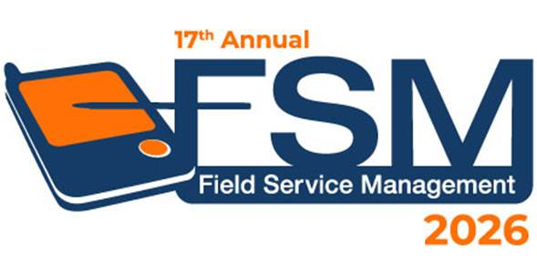
FSM Excellence Awards 2026 Application Form
Best Field Service Transformation Project
The inaugural FSM Excellence Awards are in recognition of the hard work, talent and relentless dedication the field service community has demonstrated — day in, day out, across Australia and New Zealand.
We are proud to launch the FSM Excellence Awards program this year to recognise those organisations, teams and individuals who are making the greatest contributions to the future of field service.
How to Apply
Complete this form and email it to enquire@iqpc.com.au before Friday, 12 June 2026.
Who can apply?
Any organisation, team or individual operating in the field service industry across Australia and New Zealand. Solution providers are encouraged to support their customers in submitting an application on their behalf.
How are entries judged?
All applications are assessed by an expert panel of field service leaders. Entries are scored against a structured judging criteria designed to ensure fair, consistent comparison across submissions.
When will finalists be announced?
Finalists will be notified directly on Friday, 17 July 2026.
Where are winners announced?
At the FSM Excellence Awards Night— Wednesday, 26 August 2026, Sydney, as part of the FSM Summit ANZ.
What do winners receive?
- Award trophy
- Coverage across FSM Summit ANZ website and social channels
- Featured interview and article with the FSM Summit team
General Information about You and Your Organization
Authorised by:
Date:
Name of Contact Person:
Job Title:
Organisation:
Phone Number:
Email Address:
PR Contact (for promotion of award winners):
Phone Number for PR Contact:

Please provide the following information to provide the judges better understanding of your team

Organisation Name:
Number of Field Service Locations:
Number of Field Technicians / Frontline Staff
List your top 3 technology vendors: | 1.  2.  3.
List your top 3 non-technology vendors (i.e. consultants): | 1.  2.  3.

YOUR APPLICATION FOR
Best Field Service Transformation Project
Please note: The key “showcase” for the award should be for something you’ve achieved in the past year.

Please ensure all questions are answered so the judges can accurately compare.
Please include supporting metrics wherever possible.

Q1: Describe the transformation — what was the starting point, and what needed to change?
Q2: How did you design and deliver the change? How did you bring your people along with you?
Q3: What does success look like now? Share the outcomes, data and feedback that tell the story.

Do you grant the FSM Summit team the right to publish key metrics and promote Winners of Awards? (Please mark appropriate boxes)
☐ | Grant Field Service Management Summit Team the right to publish our key metrics if we become finalists
☐ | Field Service Management Summit Team may extract the details directly from the Award application
☐ | FSM Team may utilise a condensed version for public view upon the approval of the Point of Contact  listed on the application form

Thank You!
Your application has been completed.
Please email this application and any supporting documents to enquire@iqpc.com.au

ELIGIBILITY TERMS
- The FSM Excellence Awards recognise best practice in field service management across Australia and New Zealand. Entries are open to organisations, teams and individuals operating in the field service industry.
- Entries may be submitted by the organisation, their marketing team, or a nominated third party. The name of the entering organisation and submitted project will appear on all shortlist announcements, winner communications, trophies and published materials.
- Submissions should focus on initiatives completed or substantially progressed in the past 12–18 months.
- All entries are treated with strict confidentiality. Information provided will not be shared outside the judging panel without consent.
- Event and category sponsors have no influence over entries, judging, shortlisting or winners.

